1. Sources Code

view_data_matakuliah.php🡪view

view_formMatkul.php🡪view

matakuliah.php🡪controller

2. URL

<http://localhost/pustaka_ajeng/index.php/matakuliah>

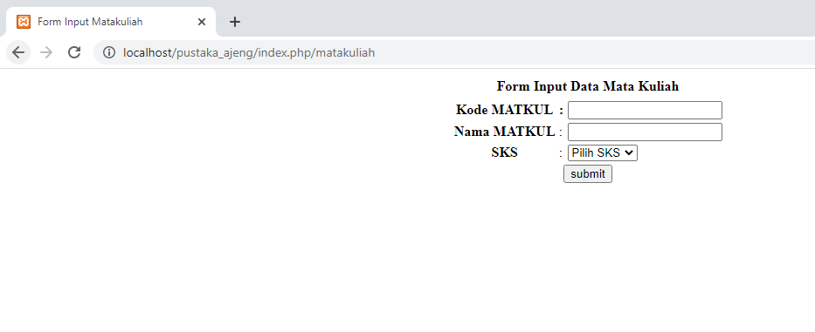3. Capture Output Program

